

**MANIPAL UNIVERSITY JAIPUR**

**School of Information Technology**

**Department of Information Technology**

**HOSPITAL**

**MANAGEMENT SYSTEM**

**Submitted by:**

**Shubham Khatri Siddharth Garg**

**219302004 219302028**

**Under the guidance of:**

**Dr. SUMIT DHARIWAL**

**Session: July- Dec: 2023**

|  |  |
| --- | --- |
| **Department of Information Technology**  **Software Engineering**  **Couse Code: IT- 3102**  **List of Experiments for B. Tech (IT) – 5th Semester** | |
| **Experiments’ No./ Week** | **Name of Experiment** |
| 1. | Write down SRS for assigned project |
| 2. | Draw the Use Case diagram of assigned project |
| 3. | System modeling and to perform the function-oriented diagram: DFD and ER  diagram based on project |
| 4 | Draw the Class diagram based and development of assigned project |
| 5 | Draw the Sequence diagram and development of assigned project |
| 6 | Draw the Collaboration diagram/ Communication diagram of assigned project |
| 7 | Draw the Activity diagram and Package diagram based on project |
| 8 | Draw the State diagram and Interaction diagram of assigned project |
| 9 | Draw the Component diagram and Deployment diagram based on project |
| 10 | Case Study on UML diagram |
| 11 | Code level Testing of assigned |
| 12 | Manual Testing of assigned project |
| 13 | Implementation of assigned project and its evaluation |

**Software Requirements Specification (SRS) for Hospital Management System**

**1. Purpose:**

The purpose of this project is to develop a comprehensive Hospital Management System (HMS) that facilitates efficient management of hospital operations, patient appointments, doctor assignments, patient admissions, and invoice generation. The system aims to streamline administrative tasks, improve patient care, and enhance overall hospital operations.

**2. Scope of Project:**

The project scope contains three main user roles: Admin, Doctor, and Patient. The system will allow administrators to manage doctors, patients, appointments, and generate invoices. Doctors will be able to access patient information, appointments, and discharge records. Patients can view doctor details, book appointments, and access their invoice upon discharge.

**3. Overview:**

The Hospital Management System will provide a user-friendly interface for administrators, doctors, and patients to perform their respective tasks. It will facilitate user registration, approval workflows, appointment scheduling, patient management.

**4. Software and Hardware Required:**

Software:

* Web development framework (Django)
* Database management system (MySQL.)
* Frontend technologies (HTML, CSS, JavaScript)
* Authentication and authorization system
* Web server (e.g., Apache, Nginx)

**5. Specifications:**

* User Roles: Admins, Doctors, and Patients with secure logins.
* Admin Abilities: Add, approve, and remove doctors; manage admissions, appointments and bills.
* Doctor Abilities: View patient details, appointments; see discharged patients.
* Patient Abilities: Create accounts, view doctor details, book appointments, view/download bills.

**Outcome:**

Our user-friendly Hospital Management System streamlines tasks. It's a tool that makes hospital life easier for everyone. Admins can run things smoothly, doctors can treat patients effectively, and patients can interact with the hospital without any hassle.

**Use case Diagram:-**

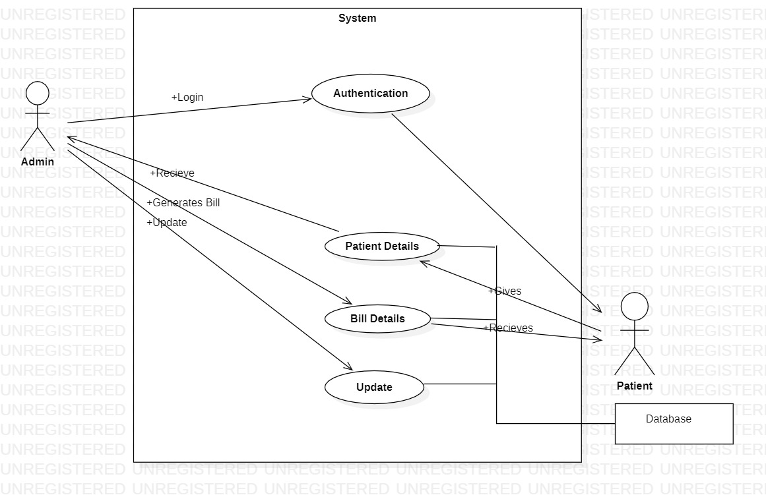

**Data Flow Diagram-:**

**DFD 0:-**

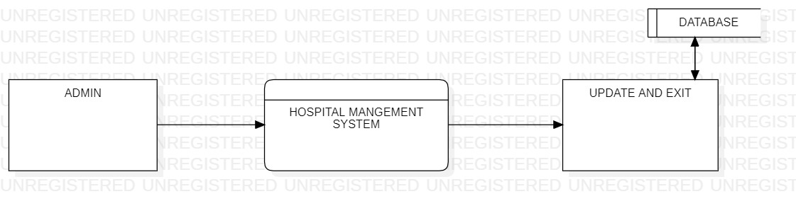

**DFD 1:-**

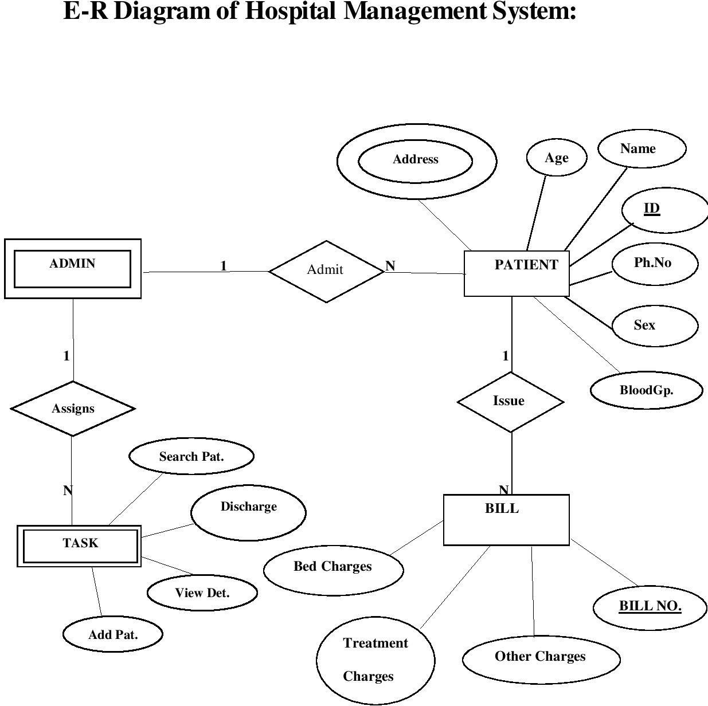

**Class Diagram:-**

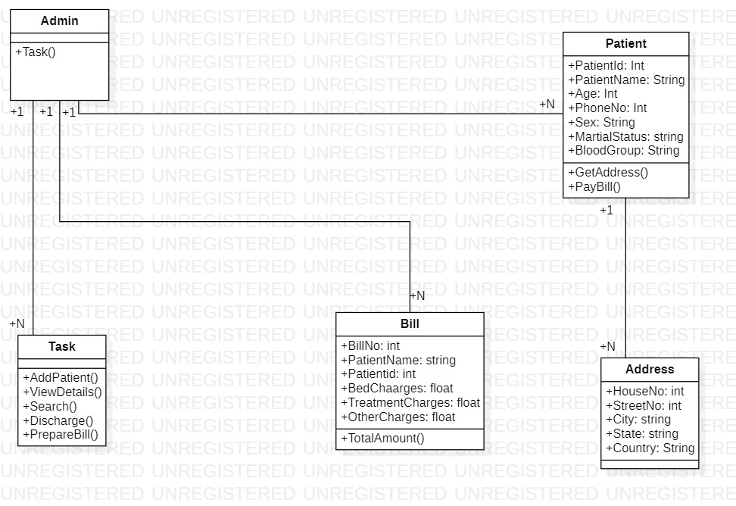

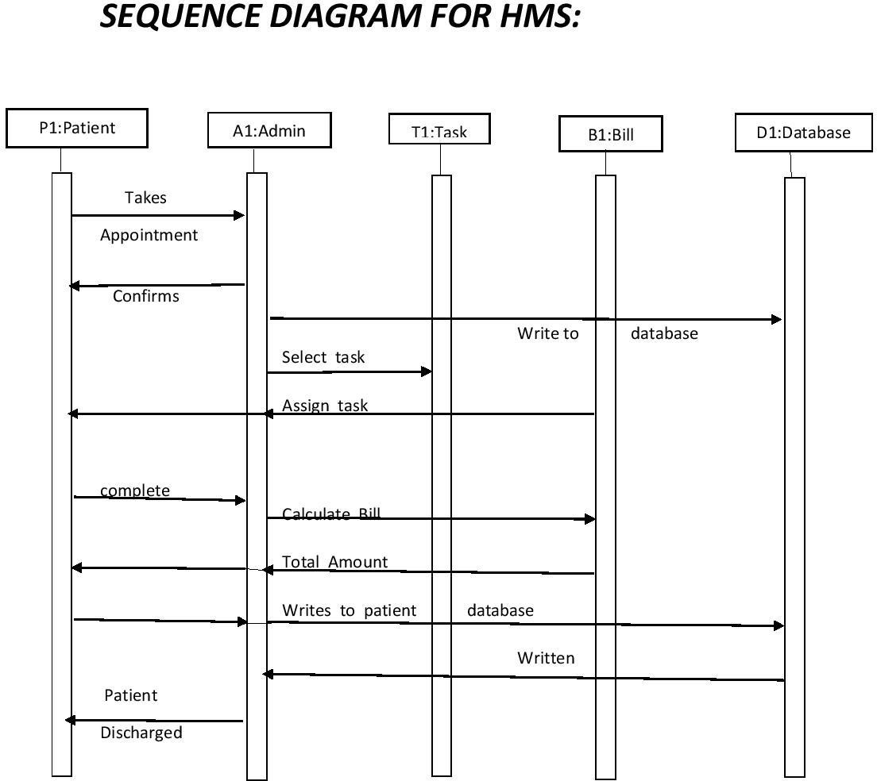

**Collaboration Diagram:-**

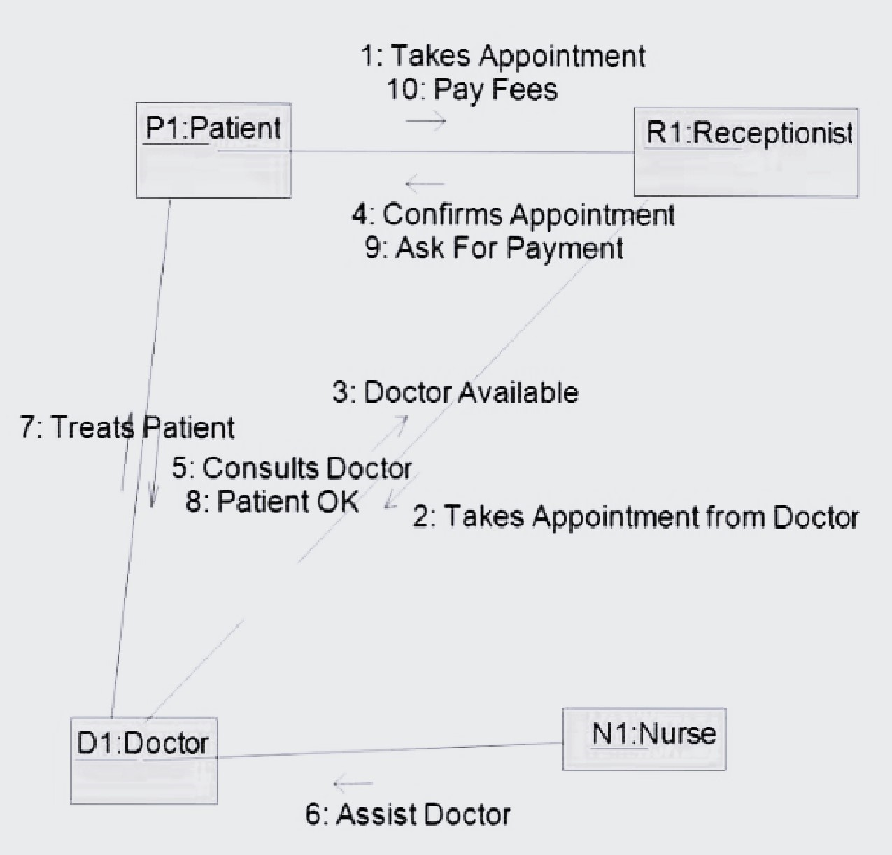

**Activity Diagram:-**

**Package Diagram:-**

**Component Diagram:-**

**STATE CHART DIAGRAM:-**

**Deployment Diagram:-**

